A World Apart

Gabriel Castagner, 001412885

Ian Yang, 001217664

Jim Wu, 001409055

Junhao Wang, 001215428

Revision 0.1

09/14/2017

1. Project Overview

**A World Apart** is a pseudo open-world rogue-lite with turn-based strategy and rpg elements. It follows the journey of a team of ISO (International Space Organization) astronauts as they try to make their way to the other side of an alien planet to rendezvous with their team.

Players will travel a world from node to node, meeting new people and making decisions based on their interactions. From time to time, they will participate in pseudo-randomly generated turn-based combat. In these **Encounters**, the player will take control of three main characters, whom they can upgrade with **Relics** found on the journey. Their goal is to keep the party alive, and make it to the other side.

As they travel this world, they might find alien factions vying for power, a lone android guarding humanity’s last hope, or a city buried in ice.

1.1 Theme / Setting / Genre

Themes: exploration, starting over, mystery

Setting: Frozen world of Ariadne

Genre: Turn based Strategy/RPG/Management

1.2 Targeted Market

The target market for this game is late teens and up. It presents an intellectual and story driven take on Rogue lites like FTL. It’s geared towards an audience who wants a challenge for the mind.

1.3 Selling Points

* procedurally generated world, enabling replayability
* rich story following various characters as they brave the icy wastelands
* Strategy based on skill, not randomness
* card-based upgrade system that allows players to adapt and try different play styles as they travel the world
* Large variety of customization, upgrades, and special skills

1.4 Premise

In 2243, the Specter space probe returns from it journey into The Hole. In its data banks, indications of a habitable planet on the other side. Still reeling from the aftermath of the Human-Machine war and unable to do anything to slow Humanity’s extinction, three world powers send three ships into the unknown, hoping to create humanity anew.

75 years pass with no news of the would-be settlers and still no way to stop the mass heating of the planet. In a last ditch attempt to save mankind, the newly found **ISO** sends one last fleet of ships to the other side. Among them, the spaceship Theseus, its crew, and 50 of the brightest minds humanity has to offer.

-----

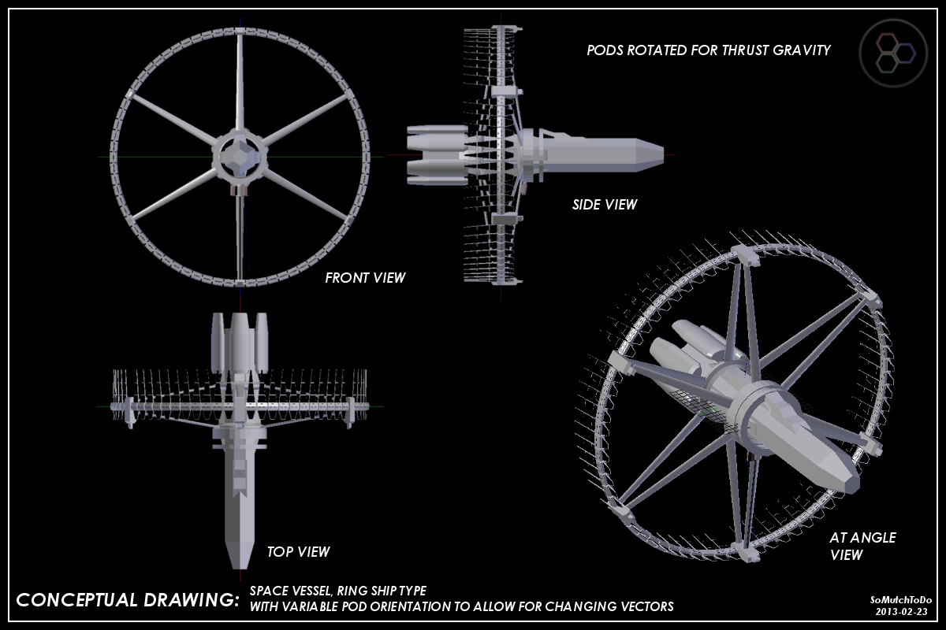

“Is that a gravity ring?”

Dr. Kroner Broese peered through the large 4-inch thick window on the side of the Theseus’ cockpit, sucking cold coffee out of what he liked to call a “kool aid bottle”. Sure enough, a large, white ring floated in front of him, barely visible above the blindingly white planet below. He looked around at the three others in the room, half of the few who’ve woken early from their long slumber, before turning his gaze back on the ivory ring in front. “One of ours?”

“No,” Captain Dhomer muttered, “looks like NorthAl make, probably from the first expedition. Alexei, you have the ship clock fixed?”

“Something must have shorted out.” said the engineer. “No idea how long we were out”

“Either way, we’re late to the party, let’s get a closer look at the ring.”

Suddenly the ship jolted, slamming Kroner into its side. “Fuck, what was that”

“Hey captain, I think we hit something” a calm voice across the comms, most likely lieutenant Armstrong. “Doris says it might be debris.”

“Alright, we’ll try to make a course change.” stated Dhomer. Another jolt, this time, more violent, followed by another, and another.

“Capt…” the comms fizz out.

“Armstrong! Armstrong!”

-----

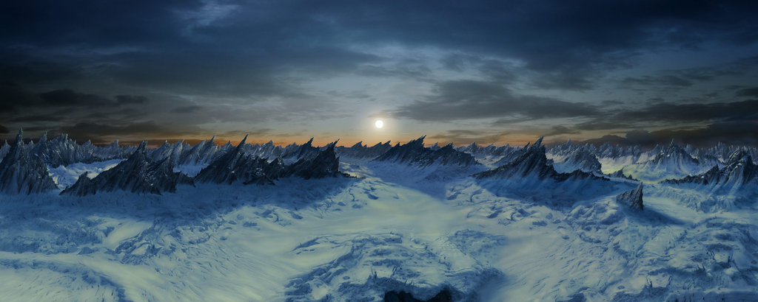

Kroner pulls his hand away from Captain Dhomer’s chest. No heartbeat. He looks around, no Lee. Given her military background, Kroner figured she was probably off getting the lay of the land. Alexei suffered a mild concussion, but he should be fine in a few hours. That’s it, no others. Kroner pulled his ISO parka up and pried open the storage room door.  At least there are plenty of supplies, maybe enough to get to the rest of the crew, wherever they are. Time to get started.

**1.5 Player Role**

The player will choose between nodes in the **Overworld** and manage the resources gathered from node to node. In the **Overworld**, they will also be able to customize characters with gear and other **Relics** picked up or won from encounters.

In **Encounters**, players will control the three characters to try to defeat a set of enemies. The combat will take place in turns, over an isometric grid. And the player will be able to control these characters to move, attack, or use certain abilities or relics.

Players should be motivated to reunite the astronauts with their team, and to keep them alive through the tough journey.

**1.6** **Win/Loss Condition**

The ultimate goal for players in AWA is to get to the other side of the planet, all they need to do is to complete the traversal. In the combat phase, the win condition is simply: defeat all enemies. In the **Overworld**, where there are random events and quests, there is no specific win condition. Certain actions and choices may yield better results, but will not result in a binary win-loss.

There are two ways the player can lose the game: total party wipe and no food. When a unit reaches 0 health, they are incapacitated. In any encounter, if all friendly units are incapacitated, the game is over. In the **Overworld**, if the player has no more food, the game is over.

**1.7 Interaction and View**

The primary interaction of the game will be done through the mouse. The mouse will allow the player to move in the **Overworld**, open menus, navigate UI, perform actions in combat and select any action or character. The mouse will be supplemented by the keyboard, which provides an alternate control scheme. There is no need for the player to use the keyboard, but one might find it easier for accessing skills and menus.

In the **Overworld**, the view will be almost top-down, with a slight angle for 3D effect. In encounters, the camera will display an isometric view for a 3D feel with 2D art.

2. Influences

**FTL - Faster than light**

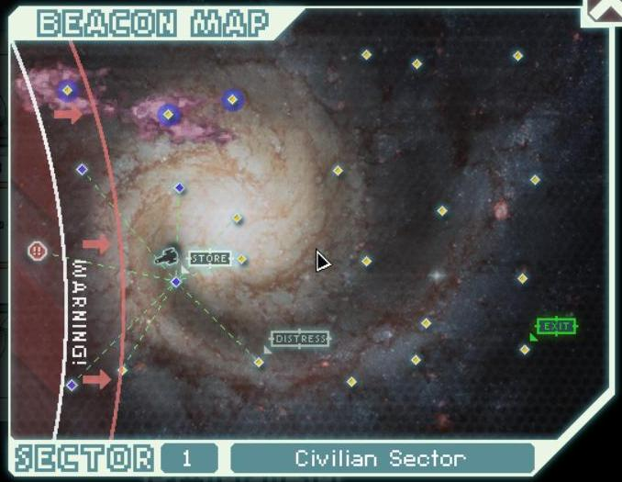

We’re borrowing the procedurally generated node-based travel system from FTL. It’s a good system for simulating the traversal of a large area, such as a planet, like in A World Apart. In FTL, Players travel from node to node, consuming fuel. This allows for random interactions, but limits the amount of time a player can stay in any sector (as they will start to lose resources)

**Renowned Explorers International Society**

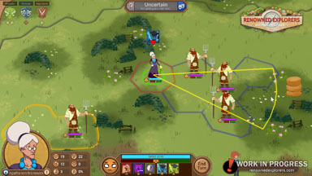

Similar to FTL, and actually about travelling across the world. We’re also borrowing the idea of using a turn based strategy with multiple heroes from RE. We will not be using the uneven gridding and the freeform skill aiming of RE, as that is difficult to aim and does not fit into the themes of the game.

**The Banner Saga**

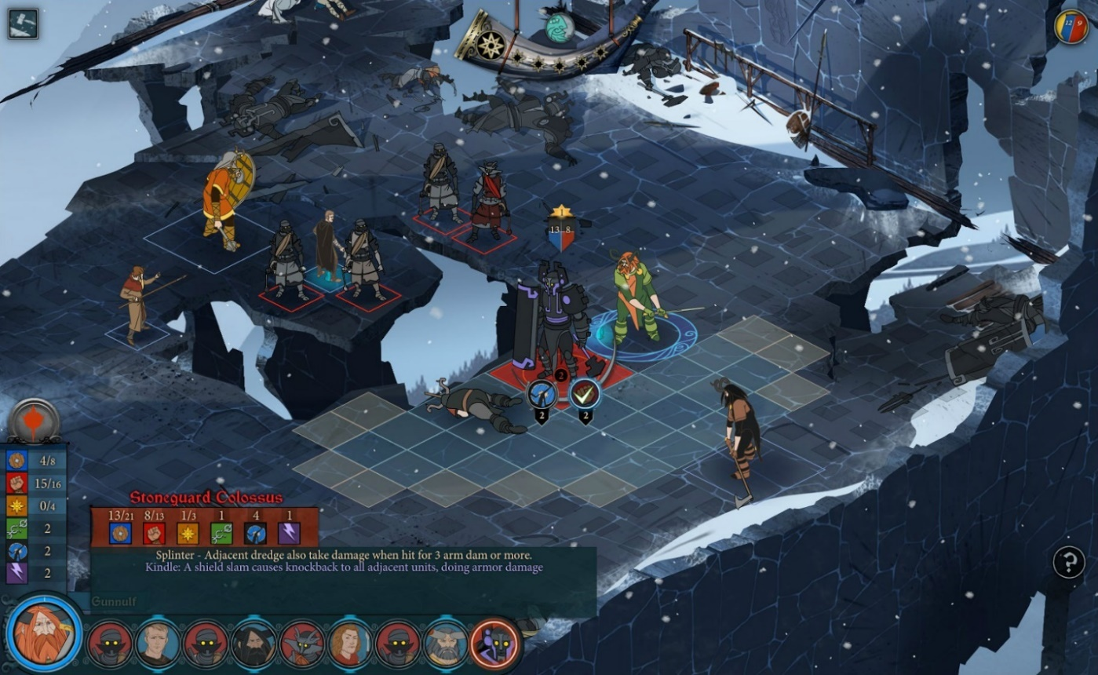

We like the non-random turn-based strategy combat in The Banner Saga. Since our game with be procedurally generated, we want to limit the RNG in other parts of the game to encourage player skill rather than random chance. We believe that strategy should be a game of low risk, high planning.

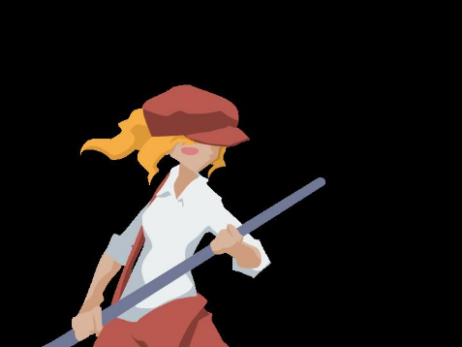

**Dustforce**

We’re borrowing the art style for the characters here for simplicity. We think it’s an easy art style to do, that can fit into the themes of AWA

3. Design Goals and Philosophy

**No Bullshit Moments**

Since the **Overworld** and loot system is random, we want to limit the amount of randomness in other parts of the game. Unlike predecessors like XCOM, we don’t want the player to lose because of a lucky shot. Therefore, the combat in the game should be well informed, and never random.

**Repetition, but not repetitiveness**

Due to the nature of procedurally generated games, players will have to play the game over and over before finally getting to the ending. As such, we don’t want the player to experience the same game every single time. This means an open world, with branching storylines, and unlocking new **Relics** for the customization system every time through. In this way, players will have a different experience every time they start the game over.

**Less talk, more rock**

Talk is needed to convey the story, but walls of text should not be used for exposition. The story will be told primarily through character dialogue, visual cues, and item descriptions. We don’t want to put people to sleep with large chunks of exposition.

**True Risk, True Skill**

AWA will not hold your hand. If you make a mistake in combat, it’ll be entirely your fault. You don’t get many second chances once your party is incapacitated, and your journey will be dictated by the decisions you make.

**Guided Aimlessness**

The world of AWA is open, which means players can choose where to go. However, we don’t want the player to wander aimlessly. As such, AWA will provide bits of information that might inform the player’s decisions, and will provide natural walls and choke points to direct the player in certain directions.

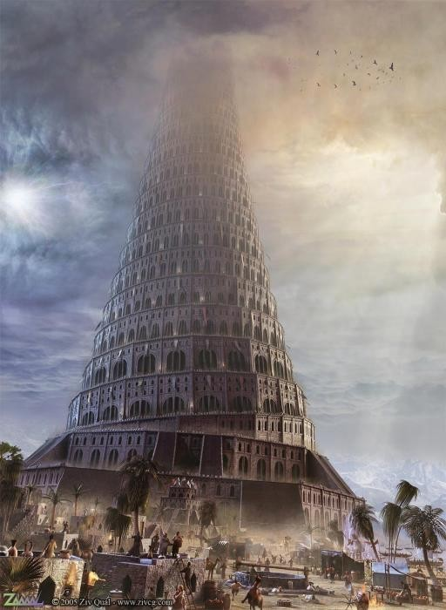4. World

When Galileo gazed up at the night sky the first time, he saw the moon, the stars, and the Hole. His father peered into the blackness of the Hole, as did his father’s father. The monarchy proclaimed it was the gateway to heaven, the clergy declared it was the eye of God. Now, a large tower burst from the capital of Rome, reaching into the heavens, built to be a bridge to the Hole, and the Spanish want to tear it down.

-----

Sergeant Hollis pried off another piece of drywall from the mound, muttering to herself. It’s been months since her squad was assigned to machine cleanup, and she’d hoped he team would have been given their well deserved leave after 7 years on the frontlines. “A few more weeks…” she mumbled, heaving a steel girder off of the pile.

She was relieved of course, for a few years near the end, it looked as if the bots would win, that would have been the end to everyone. Although, she thought, anything to put a pause to this grunt work. Just then, Hollis found herself staring at a hatch. This was new… maybe a bot bunker, used to escape the EMP, or, worse, an undiscovered production plant.

Suddenly, the ground shook, knocking Hollis on her back. Just as she was about to get up, she paused. In the distance was a trail of smoke, following what could only be an ICBM.

-----

“Launching in 5… 4… 3… 2… 1… liftoff”

An audible sigh of relief filled the room, followed by a gasp.

“NorthAl, come in NorthAl,” director McGinnis’s voice rang over the comms. He did not sound pleased.

“This is Yuri from NorthAl Command.”

“We’re detecting unidentified aircraft in our airspace, looks like your model”

“Shit” Yuri muttered, “USAU, it’s not ours, shoot if necessary”

“We already did! there’s too many of them. This is an internationally important mission NorthAl, you better not have fucked this up!”

“Like I said, It’s not ours.” Yuri checked the room, only headshakes. He sighed. At least the Britannian ship is on track.

“If we get shot down, we’ll be in the path of your ship”

“I know, there’s nothing we can do. You should have toughened your security like we suggested.”

“Fuck you NorthAl, this is 300 lives we’re talking about here, if not the fate of mankind.”

-----

“Welcome new astronauts. More than a century ago, our ancestors battled machine-kind for our freedom, but we could not prevent their retaliation. We are all aware that our planet is heating up, and fast. Last year alone, we lost hundreds of thousands of lives, and many once great cities. in 50 years, humans may no longer walk the earth.

I am not saying these things because I want you to know them, for it is an ever-present reality. I am saying them so that you may etch it into your heart. Whether you come from Britannia, The Northern Alliance, or USAU, you have all been hand picked and well trained. You may be humanity’s last hope, and what you face in the future may be ever so much more difficult than what we face here.

Here is your second chance. Here is our second chance. Go forth and settle, and perhaps we will one day meet again”

-----

“Is the Cryogen Ready?” asked Dr Rosen

“Yes, every payload has been armed, we’re waiting for the signal,” reported Dr Grant “Felix… are you sure about this?”

“not at all,” replied Rosen, nervously chewing on the tip of his pencil, “but it’s not like we have any choice… alright, give them the signal”

“okay… let there be snow”

-----

The Earth, now known as Ariadne, is a ball of snow. Having to go underground after the Cryogen Disaster, pockets of genetically modified humans became isolated from each other over the course of seven centuries. By the time the surface was finally warm enough for human habitation, many of humanity’s technologies became lost to the current generations. Technology reverted to iron age, and groups of people who no longer spoke the same language became hostile to each other over land and resources.

While maintaining most of their human features, most of the “Neo-humans” looked vastly different from each other. Some had vibrant skin as a result of previous experimentations on photosynthetic skin, while others grew disfigured from centuries of inbreeding. Eventually, these people forgot about the once-great cities buried under the ice, and became alien to the now stranded crew of the Theseus.

5. Characters

5.1 Primary Characters

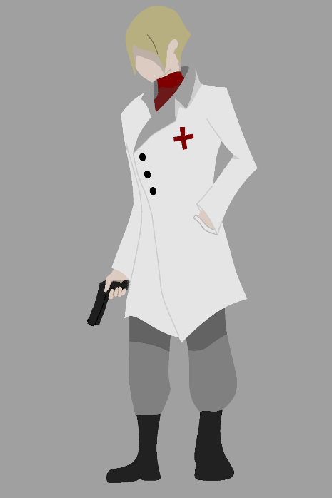

**Dr Kroner Broese**

History

An American-born German who grew up in the non-irradiated east coast, Kroner Heidel longed to escape his small town upbringing in favor of the tales he’d heard about the great cities of Britannia. At the age of 16, Kroner stowed away on a ship bound for Paris, determined to make something of himself in his new cosmopolitan home.

Unfortunately, his new home did not embrace him as he embraced it. Kroner’s days were spent scouring the lower city for food, odd jobs, and a place to stay, using his wit and dexterity for less than wholesome endeavors. His misadventures often ended in pain, and on more than one occasion, Kroner found himself performing self-surgery. Realizing he had a knack for pulling bullets from flesh, Kroner decided to use what he had saved to enroll in the University of Britannia. Graduating top of his class, Kroner, now Kroner Broese, soon became a well-known surgeon.

While parts of his past still followed him into his career, Kroner was still ISO material. Three years after basic training, he was designated the Theseus’ primary doctor.

Personality

Kroner, while a renowned surgeon respected by his peers, could not be described as a serious individual. His philosophy is that of cocky optimism, because otherwise life would just be too depressing. While at times he would, by himself, dwell on his past, Kroner chooses not to show that visage to anyone.

Motivation

Kroner wants to reunite with the rest of the team because he’s worried they won’t survive long without a doctor.

**Alexei Ivanov**

Appearance

Alexei is a fairly broad man with dark brown hair, with several cybernetic limbs.

History

A young machinery engineer who became a prominent leader in the Horizon Manufacturing group. Graduating from the Australian Institute of Technology, Alexei strayed very little from his honorable, boy-scout, small town roots. He loves his family, He loves his wife, and he loves his job.

Before being chosen to be on the ISO’s final mission, Alexei had himself wanted to find a solution to the problem of the Great Heat. His work of harnessing solar energy slowed earth’s demise by decades, but Alexei never thought it’d be enough. Realizing that he could do no more for the planet, he begrudgingly accepted the task of going on the ISO mission and maintaining their machinery. Along with his wife Alyanna, a biologist of some renown, he boarded the Theseus and prepared for the journey ahead.

Personality

You can always count on Alexei for two things, doing what he thinks is right, and being a huge pushover, not in that order. Unlike his wife Alyanna, Alexei is soft spoken and indecisive. He’s often teased by others on the mission, like Kroner, but usually doesn’t pay it much mind. He knows he’s here for a reason, and if people don’t respect him for his other qualities, they at least respect him for that.

Motivation

Alexei wants to get to the other side so that he can reunite with Alyanna. He’s also the most uncomfortable with the situation, and feels unsafe.

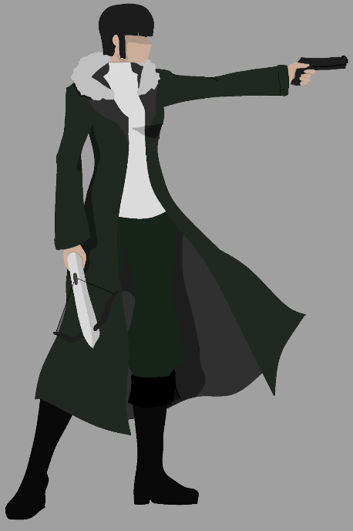**Lee Yun Long**

History

An orphan raised by her grandparents, Colonel Lee Yun Long grew up listening to her grandfather’s tales, regaled by stories of an older, united China, free from the Northern Alliance. Even as a child, Lee had fight in her, more often flipping over railings and fighting bullies than studying at school. When her grandfather died when she was 14, she faked her age and entered the Northern Marines.

While Lee was tough, being a marine was not like she thought. Over the years, she learned discipline, order, and the importance of teamwork. The years were hard, and she became harder. Three years into her service, Lee was thrust into the Indian war, a conflict that would not end until she was 23. By the end, she had earned a Red Cross, a Captain’s rank, and a disdain for the things she had to do in the war.

While she stayed on for a few more years, eventually earning the rank of Colonel, Lee was exhausted from the war, and tired of the military. At the age of 29, Lee Yun Long received an honorable discharge, and went on to become an advocate for mental health in the military.

When she was approached by ISO at the age of 32, she happily said yes. She needed to put the past behind her, and hoped that the ISO mission would mean that she could use her skills for something good.

Personality

Lee is by far the quietest of the crew of the Theseus, often preferring the quiet of her room rather than a chat over coffee. As the crew became more familiar with her, they were surprised by her snarky and often morbid comments. While she’s not one to open up, or someone you could confide in, she exudes an air of confidence and authority that puts people at ease.

Motivation

Lee sees it as her duty to protect the crew of the Theseus, and being apart from them means she can’t do her job. She’s deathly scared of what might happen to them in her absence, and doesn’t want to lose another team due to her helplessness.

5.2 NPC’s

**K-8**

An android created to guard earth’s last remaining underground seed vault. She know that she’s guarding something for ISO, but no longer remembers why or what she’s guarding. She will be hostile to anyone in the underground city.

**Usamy and Lucarts**

A race of genetically modified human beings living in the region near the initial crash site. Both races are immensely beautiful, and had Green and Red hues in their skin used for photosynthesis. As a result, the clothing of the Usamy and Lucart people are incredibly strange, consisting of heavy wool and fur for insulation, but also a transparent material placed on portions of the body, predominantly the back, that allowed for sunlight to come in.